UNIVERSITY OF SCIENCE AND TECHNOLOGY OF HANOI



LIGHTUP

**MULTIPLAYER DRAW-AND-GUESS GAME**

**GROUP PROJECT**

February 9, 2022

TEAM LightUP

https://github.com/Lib3Rt9/LightUp

**Supervisor: Dr. TRAN Giang Son**

**Submitted by Team LightUp**

**PHAM Gia Phuc**

**TRAN Dac Minh**

**DO Hoang Quan**

**DANG Gia Linh**

**PHAM Duc Thang**

**---**

**---**

**---**

**---**

**---**

**BI10-138**

**BI10-113**

**BI10-147**

**BI10-101**

**BI10-159**

Contents

**Acknowledgements** 4

**Glossary** 5

**List of Figures** 6

**Introduction** 7

**1.1.** **Context and motivation** 7

**1.2.** **Objective** 7

**1.3.** **Thesis Structure** 7

**Materials and Methods** 7

**2.1.** **Functional requirements** 7

**2.2.** **System analysis and design** 7

**A.** **Use Case Diagram** 7

**B.** **Sequence Diagram** 8

**i.** **Sign Up** 8

**ii.** **Sign In** 9

**iii.** **Select Character, Name and Flag** 10

**iv.** **Set Game Rule** 11

**v.** **Draw and Guess** 12

**C.** **Class Diagram** 12

**D.** **System Architecture** 13

**2.3.** **Implementation** 14

**A.** **Installing material for development** 14

**i.** **Install Node.js** 14

**ii.** **Creating a WebSocket server** 14

**iii.** **WebSocket** 15

**iv.** **Please don’t delete this line to keep the layout** 15

**B.** **Index page** 15

**v.** **User Interface** 15

**vi.** **Functionalities** 15

**vii.** **Page Content** 15

**viii.** **Data process: Edit and convert data (???)** 15

**ix.** **Please don’t delete this line to keep the layout** 15

**C.** **Waiting room** 15

**x.** **User Interface** 15

**xi.** **Functionalities** 15

**xii.** **Data Process** 15

**xiii.** **Please don’t delete this line to keep the layout** 15

**D.** **Gaming room** 15

**xiv.** **Creating a client that connects to server and get the total connections count** 15

**xv.** **Building chatting function with WebSockets** 17

**xvi.** **Marking a shared drawing whiteboard with Canvas and WebSocket** 19

**xvii.** **Building a multiplayer draw-and-guess game** 22

**xviii.** **Improving the game** 24

**xix.** 25

**Result and Discussion** 25

**3.1.** **Result** 25

**3.2.** **Discussion** 25

**3.3.** **User Interface** 25

**Conclusion and Future developments** 25

**4.1.** **Conclusion** 25

**4.2.** **Development** 25

**References** 25

# **Acknowledgements**

Like many new technologies, digital gaming started as something out of the world. Since the first game appeared in 1962, video games existed almost entirely as novelties passed around by programmers and technicians with access to computers, primarily at research institutions and large companies. The history of video games transitioned into a new era early in the decade, however, with the rise of the commercial video game industry.

Digital games have become a remarkable cultural phenomenon in the last ten years. The casual games sector especially has been growing rapidly in the last few years. A casual game is a video game targeted at a mass market audience, as opposed to a hardcore game, which is targeted at hobbyist gamers. Casual games may exhibit any type of gameplay and genre. They generally involve simpler rules, shorter sessions, and require less learned skill. They don't expect familiarity with a standard set of mechanics, controls, and tropes.

Most casual games have:

Fun, simple gameplay that is easy to understand

Simple user interface, operated with a mobile phone tap-and-swipe interface or a one-button mouse interface

Short sessions, so a game can be played during work breaks, while on public transportation, or while waiting in a queue anywhere

Often, familiar visual elements, like playing cards or a Match 3 grid of objects

*Aiming to give people a hilarious, funny and memorable experience after the hard-working times, we LightUp team have worked on developing the LightUp – a multiplayer draw-and-guess game on the website platform, which is really easy for anyone with any electrical devices such as smartphone, tablet and computer, etc. who want to have the joyful times.*

*Specially, we would like to express our special thanks of gratitude to our teacher Dr. TRAN Giang Son and Dr. NGHIEM Thi Phuong who gave us the opportunity to do this wonderful project on the topic Multiplayer Draw and Guess game, which also helped us in enriching experiences.*

* *Team LightUp -*

# **Glossary**

|  |  |
| --- | --- |
| **Node.js** | is an open-source, cross-platform runtime environment that allows developer create server-side and networking applications. Node.js applications are written in JavaScript and provides a rich library of various JavaScript modules which simplifies the development of web applications using Node.js |
| **Npm** (Node Package Manager) | is an online repository for the publishing of open-source Node.js projects and a command line utility for installing packages, managing versions and dependencies |
| **WebSocket** | WebSocket is a computer communications protocol, providing full-duplex communication channels over a single TCP connection. The WebSocket protocol was standardized by the IETF as RFC 6455 in 2011, and the WebSocket API in Web IDL is being standardized by the W3C. WebSocket is distinct from HTTP |
| **Server** | waits for client request messages, processes them when they arrive, and responds to the web browser with an HTTP response message (e.g., “HTTP/1.1 200 OK” for success, “HTTP/1.1 401 Unauthorized”, … etc.). A response can be many things, but the most common response from and API is JSON (JavaScript Object Notation) file |
| **Client** | is everything in a web application that is displayed or takes place on the end user device. It also sends requests (like GET, POST, DELETE, UPDATE, ... etc.) to the server |
| **JSON** | JavaScript Object Notation is a standard way of formatting data using syntax from JavaScript |
| **API** (Application Programming Interface) | Code that allows a client to interact with a server |
| **HTML** (HyperText Markup Language) | is the standard markup language for documents designed to be displayed in a web browser. |
| **CSS** (Cascading Style Sheets) | is a style sheet language used for describing the presentation of a document written in a markup language such as HTML. |
| **JavaScript** | is a high-level, often just-in-time compiled language that conforms to the ECMAScript standard.[14] It has dynamic typing, prototype-based object-orientation, and first-class functions. |
| **PHP** (Hypertext Preprocessor) | is a general-purpose scripting language geared towards web development |
| **Firebase** | Is a platform developed by Google for creating mobile and web applications  It was originally an independent company founded in 2011. |
| **URL** (Uniform Resource Locator) | is a reference to a web resource that specifies its location on a computer network and a mechanism for retrieving it |
| **HTTP** | HyperText Transfer Protocol |
| **protocol** | is an established set of rules that determine how data is transmitted between different devices in the same network |
| **network module** | is a software module that implements a specific function in a network stack, such as a data link interface, a transport protocol, or a network application |
| **UML** (Unified Modeling Language) | is a general-purpose, developmental, modeling language in the field of software engineering that is intended to provide a standard way to visualize the design of a system. |
| **UI** | User Interface |
|  |  |

# **List of Figures**

*Figure 1. Use-Case diagram*

*Figure 2.1. Sign Up sequence diagram*

*Figure 2.2. Sign In sequence diagram*

*Figure 2.3. Select Character, Name and Flag sequence diagram*

*Figure 2.4. Set game rule sequence diagram*

*Figure 2.5. Draw and Guess sequence diagram*

*Figure 3. Class diagram*

*Figure 4. System Architecture*

# **Introduction**

## **Context and motivation**

With our learning experience, we will build a multiplayer game using WebSocket. WebSocket will enable us to create event-based server-client architecture. The messages are passed between all connected browsers instantly. We will combine the Canvas drawing, JSON data packing, and several techniques learned in the university to build a draw and guess game.

## **Objective**

Our objective for this project is to develop and preliminary design a game with a purpose that with potential to build a dataset for drawing based image retrieval field. To achieve this, we:

* Develop a user-friendly interface to allow users to easily color sketches.
* Propose an entertaining game, which employs a drawing-based image retrieval paradigm in the gameplay.

## **Thesis Structure**

The rest of the thesis will be structured as following sections:

* Section 1: Introduction about project's objective.
* Section 2: Methodology.
* Section 3: Summarize the results and talk about future improvement.

# **Materials and Methods**

## **Functional requirements**

* User can join a room to play the game.
* User can choose a word then scribble to describe it.
* User can guess what another user is drawing.

## **System analysis and design**

### **Use Case Diagram**

A UML use case diagram is the primary form of system/software requirements for a new software program underdeveloped.

This use cases specify the expected behavior of a Player, the main user of the app and an Admin, who have responsibilities for maintaining the app.

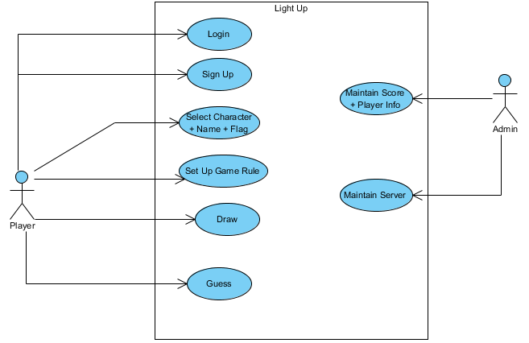

*Figure 1. Use-Case diagram*

### **Sequence Diagram**

A sequence diagram shows object interactions arranged in time sequence. It depicts the objects and classes involved in the scenario and the sequence of messages exchanged between the objects needed to carry out the functionality of the scenario. The following diagrams describe the most important functions in this project:

#### **Sign Up**

**Brief Description**

This Use-case describes how a Player sign-up for new account.

**Flow of Events**

**Basic Flow**

This use case starts when the player wishes to sign-up.

1. The Player fill in the sign-up form.
2. The form will check if valid input.
3. The server check if account exists, based on the Inputs.

**Alternative Flows**

**Invalid Input**

If invalid input format, the sign-up form will show error, Player can then input again or cancel, at which the use case ends.

**Account Exists**

If in the Basic Flow, the Player enters an existed account the system displays an error message. The Player can choose to either return to the beginning of the Basic Flow or cancel the sign-up, at which point the use case ends.

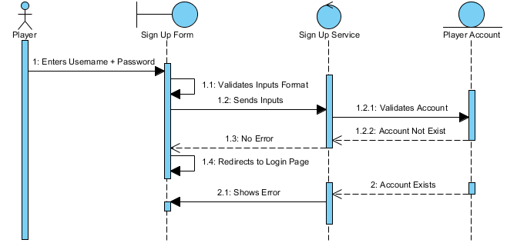

*Figure 2.1. Sign Up sequence diagram*

#### **Sign In**

**Brief Description**

This Use-case describes how a Player logs in to the App.

**Flow of Events**

**Basic Flow**

This use case starts when the Player wishes to sign-in to the Web App.

1. The Player enters his/her Username and password.
2. The server validates the entered username and password based on the Player Account database and logs the Player into the app.

**Alternative Flows**

**Invalid Username/Password**

If in the Basic Flow, the Player enters an invalid Username and/or password, the Login form displays an error message. The Player can choose to either return to the beginning of the Basic Flow or cancel the log-in (play as guest), at which point the use case ends.

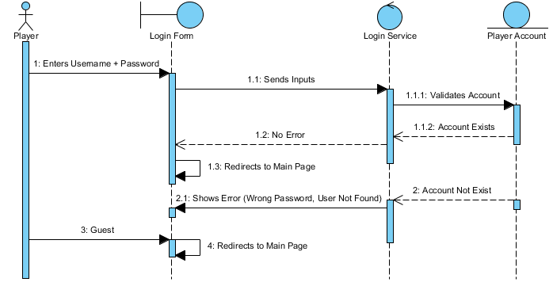

*Figure 2.2. Sign In sequence diagram*

#### **Select Character, Name and Flag**

**Brief Description**

This Use-case describes how a Player customize Character + Name + National Flag.

**Flow of Events**

**Basic Flow**

This use case starts when the Player is redirected to the main page (index).

1. The Player choose his/her character, enter name, choose flag.
2. The server added player info to firebase database when the Player click play button.

**Alternative Flows**

**Player Logged In**

If in the Basic Flow, the Player logged in in with his/her account, the page will initialize player info with his/her username and national flag.

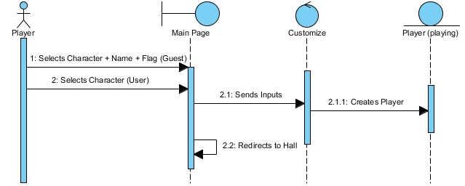

*Figure 2.3. Select Character, Name and Flag sequence diagram*

#### **Set Game Rule**

**Brief Description**

This Use-case describes how a Player setup rules before starting game.

**Flow of Events**

**Basic Flow**

This use case starts when the Player is redirected to the Hall (waiting room).

1. The First Player to enter the Hall will set up rules for the game (time limit, rounds or add custom words).
2. The server added game rule info to firebase database when the Player click start game button.

**Alternative Flows**

None.

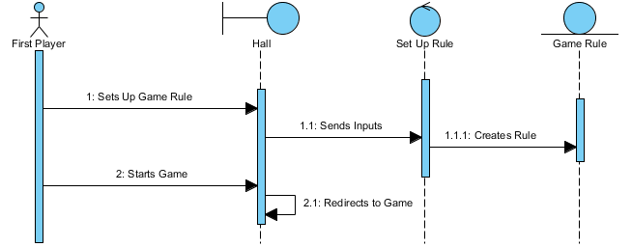

*Figure 2.4. Set game rule sequence diagram*

#### **Draw and Guess**

**Brief Description**

This Use-case describes how the Players play the game.

**Flow of Events**

**Basic Flow**

This use case starts when the Players are redirected to the Room (Game Room).

1. The Drawer chooses between 3 random generated words to draw each round.
2. The other Players guess the word through the chat, if one Player guess the word right, that Player get point, the round will end.

**Alternative Flows**

**Nobody Guess It Right**

No one get point, the round will end when it hits time limit.

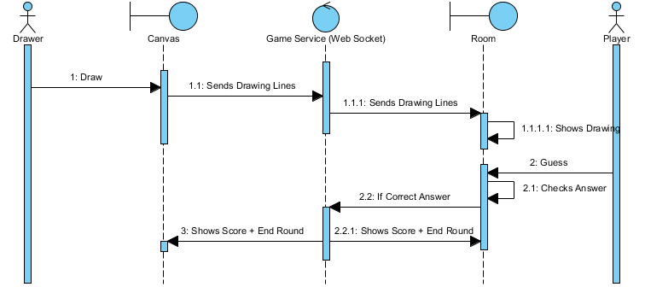

*Figure 2.5. Draw and Guess sequence diagram*

### **Class Diagram**

A class diagram models the static structure of a system. It shows relationships between classes, objects, attributes, and operations.

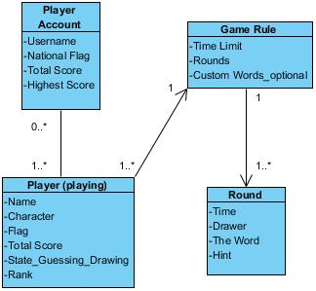

*Figure 3. Class diagram*

### **System Architecture**

Our project uses NodeJS to host a server.

Our main purpose is to create an interactive game that can handle many users interact with the others, for that reason, we use the Web Socket and its services along with client-side JavaScript functions. In this way, we are able to make and accelerate the interaction between users and make changes in the page without reloading every time.

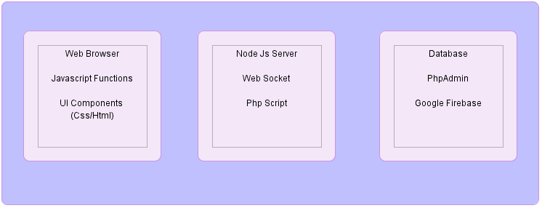

*Figure 4. System Architecture*

## **Implementation**

### **Installing material for development**

#### **Install Node.js**

We build server logic on top of this environment. The **WebSocket server** does not necessarily run on Node.js. There are different server-side implementations of the **WebSocket protocol**. We chose **Node.js** because it uses **JavaScript**, and we are familiar with it.

#### **Creating a WebSocket server**

We create a simple server logic that initialized the **WebSocket library** and listened to the connection event. In Node.JS, different functions are packed into modules. When we need a functionality in a specific module, we use require to load it. We load the **WebSocket** **module** and then initialize the server using the following code in the server logic:

var wsServer = require("ws").Server;

var server = new wsServer({ port: port });

Since the **ws** module is managed by **npm**, it's installed inside a folder called **node_modules**. When we require a library with only the name, the Node.js runtime looks for that module in the **node_modules** folder. We used **8000**

var port = 8000;

as the **server's port number**, with which a client connects to this server. We may choose a different port number, but we have to ensure that the chosen port number is not overlapped by other common server services.

server.on('connection', function(socket) {

console.log("A connection established");

});

The connection event comes with a socket argument. We will need to store this socket later because we use this object to interact with the connecting client.

#### **WebSocket**

#### **Please don’t delete this line to keep the layout**

### **Index page**

#### **User Interface**

#### **Functionalities**

#### **Page Content**

#### **Data process: Edit and convert data (???)**

#### **Please don’t delete this line to keep the layout**

### **Waiting room**

#### **User Interface**

#### **Functionalities**

* + - 1. Host a local Server with NodeJS and Express
      2. Embedded a map with Google Maps JavaScript API
      3. Geocoding Service
      4. Google Cloud Storage

#### **Data Process**

#### **Please don’t delete this line to keep the layout**

### **Gaming room**

#### **Creating a client that connects to server and get the total connections count**

We build a client that established a **WebSocket connection** to the **server** that we built in the last section. The **client** will print any messages that are received from the **server** to the console panel in the **Inspector of Developer Tools.**

* Establishing a WebSocket connection

var socket = new WebSocket(wsUrl);

The **url argument** is a string with the WebSocket URL. In our example, we run our server locally. Therefore, the URL we used is **ws://127.0.0.1:8000**, where **8000** represents the port number of the server to which we are connecting. It is 8000 because the server was listening to port 8000 when we built the server-side logic.

* About WebSocket server client events, the following table lists

The events we will use to deal with WebSockets:

|  |  |
| --- | --- |
| **Event name** | **Description** |
| Onopen | This is fired when a connection to the server is established |
| Onmessage | This is fired when any message from the server is received |
| Onclose | This is fired when the server closes the connection |
| Onerror | This is fired when there is any error in the connection |

* Sending message to all connected browsers

Once the server gets a new connection event, we send the updated count of the connection to all clients. We just need to call the **sendAll** function in the server instance with a string argument as the message. The following code snippet sends a server message to all connected browsers:

var message = "a message from server";

server.sendAll(message);

We defined two classes, **User** and **Room**, in a game.js file, which we use to manage all the connected sockets.

* Defining class and instant instance methods

In JavaScript, object-oriented programming is done by using functions and prototypes. When we create a room instance by calling new **Room()**, the browser clones all properties and methods in **Room.prototype** to the instance.

* Handling a newly connected user

For each connected user, we need to interact with them via an events handler. We add the user object into an array for easy management. We need to handle the **onclose** **event** when a user disconnects. To do this, we remove that user from the array.

* Exporting modules

After defining our classes in the game.js file, we exported them. By **exporting** them to the **module**, we can **import** them in the other file by using the **require method**, as follows:

var User = require('./game').User;

var Room = require('./game').Room;

* Sending messages to the client

**WebSocket** have the ability to send messages from the server to a user. Normally, the client requests the server and then the server responds. In a socket server, all users are connected, so messages can be triggered and sent in both directions.

Room.prototype.send = function(message) {

for (var i=0, len=this.users.length; i<len; i++) {

this.users[i].socket.send(message);

}

};

Then listen the message on the client:

// on message event

WebSocketGame.socket.onmessage = function(e) {

console.log(e.data);

};

* + - 1. **Host a local server with NodeJS and WebSocket (this no more use)**
         1. Before we go further about hosting a local Sever, we would like to briefly define a few important terms and concepts:
      2. **Create a WebSocket server (no more use too)**

#### **Building chatting function with WebSockets**

We want to build a chat room where users can type a message in their respective browsers and send the message to all the connected users instantly.

* Sending a message to the server

We add an **input text field** for the users to type some text there and send it out, the user input a message and then the text is sent as a message to the WebSocket server. The server will then forward the message to **all connected browsers**. Once a browser receives the message, it displays it in the chat area. In this case, the users are connected to the instant chat room once they load the web page. The server will then print the **received message** in the terminal.

$("#send").click(sendMessage);

$("#chat-input").keypress(function(event) {

if (event.keyCode === 13) {

sendMessage();

}

});

function sendMessage() {

var message = $("#chat-input").val();

wsGame.socket.send(message);

$("#chat-input").val("");

}

* Sending a message from the client to the server

In order to **send a message** from the client to the server, we call the following send method in the WebSocket instance:

WebSocketGame.socket.send(message);

In the following code snippet from our example, we get the message from the input text field and **send it to the server**:

var message = $("#chat-input").val();

WebSocketGame.socket.send(message);

* Receiving a message on the server side

On the **server side**, we need to handle the message we just sent from the client. We have an event named message in the connection instance in the **WebSocket node.js library**. We can **listen** to the connection message event to receive a message from each client connection.

* Sending every received message on the server side to create a chat room

The server could **receive** messages sent from browsers. However, the server does nothing except print the received messages in the terminal. We learned how a server sends the connection count to all the connected clients. We also learned how the client sends a message to the server. Therefore, we add some logic to the server to send the messages out by combining these two techniques to let the server send the received messages to all the connected users.

user.socket.on("message", function(message){

console.log("Receive message from " + user.id + ": " + message);

// send to all users in room.

var msg = "User " + user.id + " said: " + message;

room.sendAll(msg);

});

#### **Marking a shared drawing whiteboard with Canvas and WebSocket**

We want a **shared sketchpad**. Anyone can draw something on the sketchpad and all others can view it. We learned how messages are **communicated** between clients and servers. We will go further and send drawing data.

* Building a local drawing sketchpad

Before we work with data sending and server handling, we focus on making a drawing whiteboard. We use the **Canvas** to build a local **drawing sketchpad**. We created a local drawing pad. This is like a whiteboard where the player can draw in the Canvas by dragging the mouse. However, the drawing data is not sent to the server yet all drawings are only displayed locally.

Firstly, create a canvas in the html file

<canvas id="drawing-pad"></canvas>

Then, replace the **wsGame global object** with the following variable at the top of the JavaScript file:

var WebSocketGame = {

// indicates if it is drawing now.

isDrawing : false,

// the starting point of next line drawing.

startX : 0,

startY : 0,

}

// canvas context

var canvas = document.getElementById('drawing-pad');

var ctx = canvas.getContext('2d');

* Drawing with Canvas

When we draw something on the computer, it often means that we **click** on the **Canvas** and **drag the mouse (or pen)**. The line is drawn **until** the **mouse button** is **up**. Then, the user clicks on another place and drags again to draw lines. In our example, we have a Boolean flag named **isDrawing** to indicate whether the user is drawing. The **isDrawing flag** is **false** by default.

When the mouse button is **at a point**, we **turn the flag to true**. When the mouse is moving, we draw a line between the moved point and the last point when the mouse button was. Then, we set the isDrawing flag to false when the mouse button is up. This is how the drawing logic works.

* Sending the drawing to all connected clients

To go further, it is necessary to **send** the **drawing data** to the server and let the server send them to **all connected players**.

To achieve it, we have created two constants in game.js file:

// Constants

var LINE_SEGMENT = 0;

var CHAT_MESSAGE = 1;

After that, the following code is added at the beginning of the **Room.prototype.addUser** method:

this.users.push(user);

var room = this;

// tell others that someone joins the room

var data = {

dataType: CHAT_MESSAGE,

sender: "Server",

message: "Welcome " + user.id + " joining the party. Total connection: " + this.users.length,

};

room.sendAll(JSON.stringify(data));

Moreover, **JSON-formatted string** is used for communicating both drawing actions and chat messages with the usage of:

user.socket.on("message", function(message){

console.log("Receive message from " + user.id + ": " + message);

// construct the message

var data = JSON.parse(message);

if (data.dataType === CHAT_MESSAGE) {

// add the sender information into the message data object.

data.sender = user.id;

}

// send to all clients in room.

room.sendAll(JSON.stringify(data));

});

on the message event handler.

When handling the message on the **client-side**, we **converted** the **JSON-formatted string** back to **data object**. If the data is a **chat message**, we then displayed it as the chat history, otherwise, it is being **drawled** **in the Canvas** by using **parse**:

var data = JSON.parse(e.data);

* Defining a data object to communicate between the client and the server

In order to communicate correctly between the server and clients when there is a lot of data packed into one message, we have to define a data object that both the client and server understand.

There are several properties in the data object. The following table lists the properties and why we need them:

|  |  |
| --- | --- |
| **Property name** | **Why we need it** |
| dataType | This is an important property that helps us to understand the entire data. The data is either a chat message or drawing line segment data |
| sender | If the data is a chat message, the client needs to know who sent the message. |
| message | If the data is a chat message, the client needs to know who sent the message. |
| startX | When the data type is a drawing line segment, we include the xy coordinates of the starting point of the line. |
| startY |
| endX | When the data type is a drawing line segment, we include the x/y coordinates of the ending point of the line. |
| endY |

* Packing the drawing into JSON for sending work

We used the **JSON.stringify function** when we stored a JavaScript object into a **JSON-formatted string** in the local storage. Now, we need to send the data in string format between the server and the client. We use the same method to pack the drawing lines data into an object and send it as a **JSON string**

var data = {};

wsGame.socket.send(JSON.stringify(data));

* Recreating the drawing after receiving them from other clients

The **JSON parsing** often comes as a pair of **stringify**. When we receive a message from the server, we have to parse it to the JavaScript object. The following code on the client side parses the data and either updates the chat history or draws a line based on the data:

#### **Building a multiplayer draw-and-guess game**

We built an instant **chat room** earlier. Also, we built a **multiuser sketchpad**. Now we **combine** these two techniques and build a **draw-and-guess game.** A draw-and-guess game is a game in which **one player** is **given a word** to draw. All **other players** do not know the word and **guess the word** **according to the drawing**. The one who draws and who correctly guesses the word earn points.

We need a few more constants to determine different states during the game play.

GAME_LOGIC : 2,

// Constant for game logic state

WAITING_TO_START : 0,

GAME_START : 1,

GAME_OVER : 2,

GAME_RESTART : 3,

When the client receives a message from the server, it **parses** it and **checks** whether it is a chat message or a line drawing. We have another type of message named **GAME_LOGIC** for handling the game logic. The game logic message contains different data for **different game states**.

Finally, there is one last step in the **client-side logic**. We want to **restart** the game by sending a restart signal to the server. At the same time, we clear the drawing and chat history. To do this, we add the lines inside the **websocket.js** file:

// restart button

$("#restart").hide();

$("#restart").click(function() {

canvas.width = canvas.width;

$("#chat-history").html("");

$("#chat-history").append("<li>Restarting Game.</li>");

// pack the restart message into an object.

var data = {};

data.dataType = WebSocketGame.GAME_LOGIC;

data.gameState = WebSocketGame.GAME_RESTART;

WebSocketGame.socket.send(JSON.stringify(data));

$("#restart").hide();

});

The server side was just in charge of sending any incoming message to all connected browsers. This is not enough for a multiplayer game. The server will act as the game master that controls the game flow and determination of the winning condition. We extend the **Room** class with **gameRoom** that can handle the game flow in game.js file.

This is the constructor function of a new class called **gameRoom**, which initializes **game logic**:

function gameRoom() {

// current turn

this.playerTurn = 0;

this.wordList = ["one"];

this.currentAnswer = undefined;

this.currentGameState = WAITING_TO_START;

// send game state to all players

var gameLogicData ={

dataType: GAME_LOGIC,

gameState: WAITING_TO_START

};

console.log(this);

this.sendAll(JSON.stringify(gameLogicData));

};

This way, the gameRoom keeps the original **room’s** **addUser** function and we can add extra logics and some features like randomly defines a drawer or a word in playing time.

At last, we export the gameRoom class so that other files, such as server.js, can access the gameRoom class:

module.exports.gameRoom = gameRoom;

In addition, in **server.js**, we must call our new **gameRoom constructor** instead of the generic Room one.

* Game flow controlling:

There are several states in the game flow. Before the game starts, the connected players are waiting for the game to start. Once there are enough connections for the multiplayer game, the server sends a game logic message to all the players to inform them of the start of the game.

When the game is over, the server sends a game over state to all the players. Then, the game finishes and the game logic halt until any player clicks on the restart button. Once the restart button is clicked, the client sends a game restart state to the server instructing the server to prepare a new game. Then, the game starts again.

#### **Improving the game**

* + - 1. **Styles**

Css is used to improve its visual outlook with some decorative images.

* + - 1. **Better drawing**

To give user more choices when playing with the game, we added some features which contain:

* Color of drawing lines

The game provides 6 constant colors: white, black, red, blue, green, yellow and a color picker to customize the picture

* Thickness of drawing lines

By default, the thickness of the pen is 2 with the color of black, however drawer can change the thickness with a wide range: from 1 to 100, this will increase the joy of expressing the imagination, we believe.

* Shape drawing

Yet, just the normal lines are not enough, therefore, we give user ability of drawing the straight line, circle and polygons. This way, it is easier for drawer to create greatest picture in play-time.

* + - 1. **Bonus features**

Since not every time, every drawing lines is correct or fit the imagination of drawer, we also provide the feature of undoing action – drawing line in this case – and the ability to clear erase everything in the canvas pad, thus, it is better for drawer to fix or even reconstruct the imagination of the masterpieces.

Besides, we also added some functions to help stabilize the working process of the game like take and restore the snapshot of the canvas drawing pad.

#### 

* + - 1. D

# **Result and Discussion**

## **Result**

## **Discussion**

## **User Interface**

Index page

Waiting room

Gaming room

# **Conclusion and Future developments**

## **Conclusion**

In conclusion, we have built a multiplayer game with the help of WebSocket. WebSocket enable us to create event-based server-client architecture. The messages are passed between all connected browsers instantly. We have combined the Canvas drawing, JSON data packing, and several techniques to build the draw-and-guess game.

The main components of the application have been implemented:

* **Name and Character choosing function**: Player can choose the name, character and avatar which are shown in the game
* **Rule set function**: Player can set custom words for the word list when playing to have the best experiences
* **Drawing and chatting function**: Player can draw in multiple ways, share the masterpieces as well as chatting with others.

## **Development**

* Grading system
* More stable in play time
* Optimize and update the game
* Update database to store information of the game
* Other platforms optimization, such as Mobile platform
* More administrative features like kick somebody out of the room
* More game rooms, custom game rounds, more timing choices
* Sharing options

# **References**

Gaming place:

<http://lightup.42web.io/>

Gaming documents:

<https://wikipedia.org/>

[https://en.wikipedia.org/...video_game](https://en.wikipedia.org/wiki/Early_history_of_video_games%23Defining_the_video_game)

<https://en.wikipedia.org/wiki/Casual_game>

Node.js WebSocket documents:

[https://en.wikipedia.org/wiki/websocket](https://en.wikipedia.org/wiki/WebSocket#:~:text=WebSocket_is_a_computer_communications,WebSocket_is_distinct_from_HTTP.)

<https://nodejs.org/>

Firebase database documents:

[https://firebase.google.com/firebase](https://firebase.google.com/?gclid=CjwKCAiAo4OQBhBBEiwA5KWu_1RT1sUlPBYbGXeuh7axmNiJi2yePA0MYsKfMvYsP0vfUxx_bAu_PBoC4McQAvD_BwE&gclsrc=aw.ds)

UML diagram tool:

<https://www.visual-paradigm.com/>